Modeling using Discrete Event Simulation:

Discrete event simulation is a form of computer based modeling that provides an intuitive and flexible approach to representing complex systems. Our model simulates the dynamics of main, and casual sexual partnerships, with behavioral model parameters estimated form sexual network data.

Structural development:

The core concepts of DES are entities, attributes, events, resources, queues, and time. In disease modeling studies, the network model will generally consist of a set of individuals connected by contacts, where it is assumed that the contacts are such that if a transmission event could take place. The use of the most important feature is how well individuals are connected. In pair-formation models developed by Dietz and Hadeler[3] , Waldstätter[4], and Kretzschmar and Dietz[5] ,the pair-formation framework allow modeling of differential infection risk among persons who are single or paired, and it has been widely used in a number of other mathematical models of sexually transmitted infections[6-9].

The model include compartments that stratify the population by age, sex, partnership status, sexual risk behavior, and infection status. Transmission of sexual disease in the model occurs via unprotected sex in heterosexual partnerships[Fig1].

Predictors of partnership formation varies by partnership type,risk level,, age mixing, and status-unknown partnership. In our model, there are 2 partnership statuses that are mutually exclusive. Entity can be part of the unpaired(“single”)population or paired(“married”), unpaired population can have casual partners at age-specific rates. Casual partners represent short term relationships, and they are modeled as instantaneous partnerships. Behavioral parameters were informed by the National Survey of Family Growth[1]. Parameters and their prior distributions[2] are shown in Table 1.

|  |  |  |
| --- | --- | --- |
| Table 1. Description of parameters governing testing, natural recovery and transmission probability | | |
| Parameter / Variable | Description | Distribution |
| Population size | Population size for each age group | Uniformly distributed |
| Time step | Time step implemented in the model | A day |
| High risk | Fraction of the population defined as high risk | 10% (Assumption*) |
| Low risk | Fraction of the population defined as low risk | 90% (Assumption*) |
| Testing symptomatic individuals | | |
| Women | Testing of symptomatic women | 1/(52*(0.079+0.072*Beta(4,4))) |
| Men | Testing of symptomatic men | 1/(52*(0.079+0.072*Beta(4,4))) |
| Casual partners | | |
| High risk(HR) | Single, 65-79 HR | Beta(3,60) |
|  | Single, 80-95 HR | Beta(3,400) |
| Low risk(LR) | Single, 65-79 LR | Beta(1,160) |
|  | Single, 80-95 LR | Beta(1,160) |
| Among paired | | |
| High risk(HR) | Single, 65-79 HR | Beta(10,70) |
| Low risk(LR) | Single, 80-95 LR | Beta(10,100) |
| Treatment success(efficiency of antibiotics) |  | Beta(190,8) |
| Natural recovery | | |
| Women |  | 1/(52*(1.13+0.5*Beta(4,4.969))) |
| Men |  | 1/(52*(1.13+0.5*Beta(4,4.969))) |
| Transmission probability | Per act probability | Beta(5.5, 50) |
| *we chose to fix the fraction of the population defined as high risk at constant 10%, but accommodate uncertainty in levels of risk behavior by varying the partner change rates by relationship states and age, in each of the risk groups. Defining a set proportion of the population to belong to a risk group and varying partner change rates is a modeling convention | | |
|
|
|

Fig1:

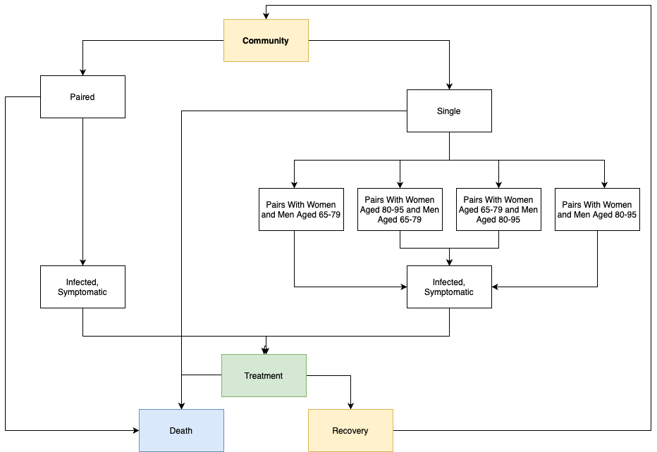

Literature Survey:

Propagation of Sexually transmitted diseases (STD) is modeled mainly based on the option of the social network that describes the contact between individuals. Perhaps the initial form of these models was STDSIM, created in the late 1990s and utilized in numerous HIV modeling studies [10]. The network models have become increasingly difficult with the use of information from the populaces under examination. One such model [11] depicts a collection of work around demonstrating the HIV pandemic in Vancouver, which incorporates a system model of infusing drug clients and female sex laborers, with the point of evaluating the viability of various control methodologies. To model STDs, a network model is generated with an analogy of vertices representing persons and edges representing contacts.A transmission event can happen in cases of connected edges, thus making the probability distribution of the number of edges of each node a very salient feature. Each of the edges can have various weights which directly relate to the type of interactions between the individuals. For instance, the netwrok can be modeled in three levels of interactions that determine heterosexual contact:0, no contact; 1, spousal partnership; 2, non-spousal partnership[12].

Although, this can be very difficult in cases with large datasets as developing models with social networks would need a large number of people to have expertise on the different fields involved like statistics, computer science, ethnography, medicine among others. An alternative model can be built by considering mainly a few concise statistics regarding the extensive data[13]. These contact networks make way for analysing the break of disease transmissions between persons by the use of condoms and other precautionary measures. This helps understand the impact of superspreaders as well. There are other models of STDs that are based on System Dynamics and other concepts. These are mainly aimed for making decisions on how to allocate resources to reduce STDs in a targeted testing program[14].

REFERENCES

1. National Center for Health Statistics. National Survey of Family Growth. <https://www.cdc.gov/nchs/nsfg/index.htm>. Updated November 8, 2018. Accessed November 19, 2018.

2.@article{rönn_tuite_menzies_wolf_gift_chesson_torrone_berruti_mazzola_galer_et al._2019, title={The Impact of Screening and Partner Notification on Chlamydia Prevalence and Numbers of Infections Averted in the United States, 2000–2015: Evaluation of Epidemiologic Trends Using a Pair-Formation Transmission Model}, volume={188}, DOI={10.1093/aje/kwy272}, number={3}, journal={American Journal of Epidemiology}, author={Rönn, Minttu M and Tuite, Ashleigh R and Menzies, Nicolas A and Wolf, Emory E and Gift, Thomas L and Chesson, Harrell W and Torrone, Elizabeth and Berruti, Andrés and Mazzola, Emanuele and Galer, Kara and et al.}, year={2019}, month={Apr}, pages={545–554}}

3. @article{dietz_hadeler_1988, title={Epidemiological models for sexually transmitted diseases}, volume={26}, DOI={10.1007/bf00280169}, number={1}, journal={Journal of Mathematical Biology}, author={Dietz, K. and Hadeler, K. P.}, year={1988}, pages={1–25}}

4.@article{dietz_hadeler_1988, title={Epidemiological models for sexually transmitted diseases}, volume={26}, DOI={10.1007/bf00280169}, number={1}, journal={Journal of Mathematical Biology}, author={Dietz, K. and Hadeler, K. P.}, year={1988}, pages={1–25}}

5.@article{dietz_hadeler_1988, title={Epidemiological models for sexually transmitted diseases}, volume={26}, DOI={10.1007/bf00280169}, number={1}, journal={Journal of Mathematical Biology}, author={Dietz, K. and Hadeler, K. P.}, year={1988}, pages={1–25}}

6.@article{heijne_althaus_herzog_kretzschmar_low_2011, title={The Role of Reinfection and Partner Notification in the Efficacy of Chlamydia Screening Programs}, volume={203}, DOI={10.1093/infdis/jiq050}, number={3}, journal={The Journal of Infectious Diseases}, author={Heijne, Janneke C.m. and Althaus, Christian L. and Herzog, Sereina A. and Kretzschmar, Mirjam and Low, Nicola}, year={2011}, month={Jan}, pages={372–377}}

7. @article{powers_ghani_miller_hoffman_pettifor_kamanga_martinson_cohen_2011, title={The role of acute and early HIV infection in the spread of HIV and implications for transmission prevention strategies in Lilongwe, Malawi: a modelling study}, volume={378}, DOI={10.1016/s0140-6736(11)60842-8}, number={9787}, journal={The Lancet}, author={Powers, Kimberly A and Ghani, Azra C and Miller, William C and Hoffman, Irving F and Pettifor, Audrey E and Kamanga, Gift and Martinson, Francis Ea and Cohen, Myron S}, year={2011}, pages={256–268}}

8.@article{xiridou_geskus_wit_coutinho_kretzschmar_2003, title={The contribution of steady and casual partnerships to the incidence of HIV infection among homosexual men in Amsterdam}, volume={17}, DOI={10.1097/00002030-200305020-00012}, number={7}, journal={Aids}, author={Xiridou, Maria and Geskus, Ronald and Wit, John De and Coutinho, Roel and Kretzschmar, Mirjam}, year={2003}, pages={1029–1038}}

9.@article{ferguson_garnett_2000, title={More Realistic Models of Sexually Transmitted Disease Transmission Dynamics}, volume={27}, DOI={10.1097/00007435-200011000-00008}, number={10}, journal={Sexually Transmitted Diseases}, author={Ferguson, Neil M. and Garnett, Geoffrey P.}, year={2000}, pages={600–609}}

10. @article{10.2307/25062378,

ISSN = {00922102, 1526551X},

URL = {http://www.jstor.org/stable/25062378},

abstract = {STDSIM is a dynamic stochastic simulation model for decision support in attempts to control sexually transmitted diseases (STDs). It describes the mechanisms responsible for the transmission of five STDs, including HIV/AIDS, at the level of individuals. A large variety of outcome measures (for example, STD prevalence, incidence, and mortality) can be calculated for different groups of the population (for example, adolescents, prostitutes, pregnant women, and migrants) to evaluate the effects of alternative STD control interventions. We designed the model to support decision making for different settings in developing countries, with Nairobi (Kenya) as its first application area. The model adequately describes STD prevalences and the time-trend of HIV prevalence measured in Nairobi. As an illustration of the possibilities of the model, we show model predictions of the effects of improved STD care and increased condom use on the prevalence and incidence of HIV.},

author = {Catharina P. B. Van der Ploeg and Carina Van Vliet and Sake J. De Vlas and Jeckoniah O. Ndinya-Achola and Lieve Fransen and Gerrit J. Van Oortmarssen and J. Dik F. Habbema},

journal = {Interfaces},

number = {3},

pages = {84--100},

publisher = {INFORMS},

title = {STDSIM: A Microsimulation Model for Decision Support in STD Control},

volume = {28},

year = {1998}

}

11. Landsberg A, Kerr T, Milloy MJ, et al. Declining trends in exposures to harmful policing among people who inject drugs in Vancouver, Canada. J Int AIDS Soc. 2016;19(4 Suppl 3):20729. Published 2016 Jul 18. doi:10.7448/IAS.19.4.20729

12. @article{c030e9dad6134c6e9a9d18e61b852e99,

title = "Inferring model parameters in network-based disease simulation",

abstract = "Many models of infectious disease ignore the underlying contact structure through which the disease spreads. However, in order to evaluate the efficacy of certain disease control interventions, it may be important to include this network structure. We present a network modeling framework of the spread of disease and a methodology for inferring important model parameters, such as those governing network structure and network dynamics, from readily available data sources. This is a general and flexible framework with wide applicability to modeling the spread of disease through sexual or close contact networks. To illustrate, we apply this modeling framework to evaluate HIV control programs in sub-Saharan Africa, including programs aimed at concurrent partnership reduction, reductions in risky sexual behavior, and scale up of HIV treatment.",

keywords = "Concurrent partnerships, Network dynamics, Sexually transmitted diseases, Stochastic simulation",

author = "Enns, {Eva A.} and Brandeau, {Margaret L.}",

year = "2011",

month = "6",

day = "1",

doi = "10.1007/s10729-011-9150-2",

language = "English (US)",

volume = "14",

pages = "174--188",

journal = "Health Care Management Science",

issn = "1386-9620",

publisher = "Kluwer Academic Publishers",

number = "2",

}

13.@dataset{dataset,

author = {Zhang, Yu-Xuan and Barry, Johanna and Moore, David and Amitay, Sygal},

year = {2013},

month = {01},

pages = {},

title = {Zhang et al 2012 PLoS One}

}

14. @Article{Kok2015,

author="Kok, Sarah

and Rutherford, Alexander R.

and Gustafson, Reka

and Barrios, Rolando

and Montaner, Julio S. G.

and Vasarhelyi, Krisztina

and {on behalf of the Vancouver HIV Testing Program Modelling Group}",

title="Optimizing an HIV testing program using a system dynamics model of the continuum of care",journal="Health Care Management Science",

year="2015",month="Sep",day="01",volume="18",number="3",pages="334--362",

abstract="Realizing the full individual and population-wide benefits of antiretroviral therapy for human immunodeficiency virus (HIV) infection requires an efficient mechanism of HIV-related health service delivery. We developed a system dynamics model of the continuum of HIV care in Vancouver, Canada, which reflects key activities and decisions in the delivery of antiretroviral therapy, including HIV testing, linkage to care, and long-term retention in care and treatment. To measure the influence of operational interventions on population health outcomes, we incorporated an HIV transmission component into the model. We determined optimal resource allocations among targeted and routine testing programs to minimize new HIV infections over five years in Vancouver. Simulation scenarios assumed various constraints informed by the local health policy. The project was conducted in close collaboration with the local health care providers, Vancouver Coastal Health Authority and Providence Health Care.",

issn="1572-9389", doi="10.1007/s10729-014-9312-0", url="https://doi.org/10.1007/s10729-014-9312-0"}